**Digital Music Store Analysis**

**SQL Project**

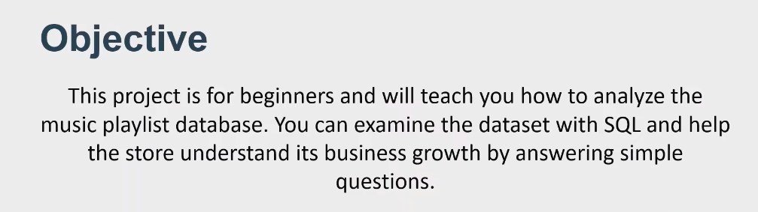

**Database Schema**

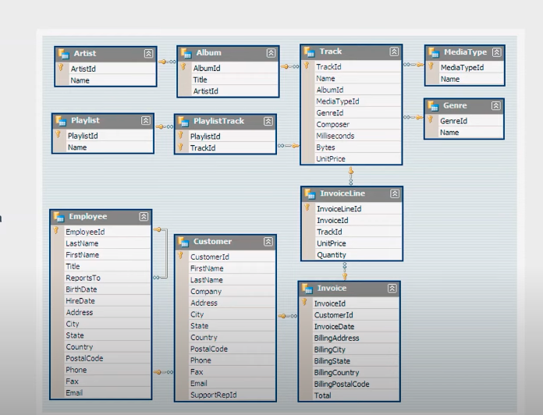

**Steps to Initialise the Music Database in PostgreSQL**

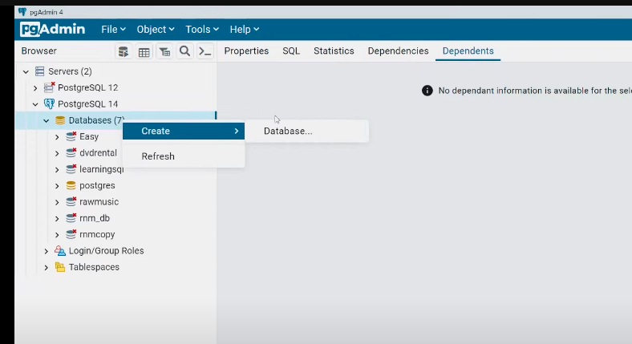

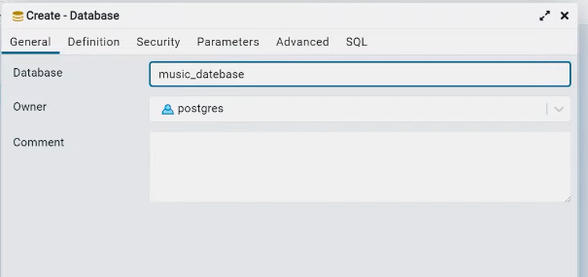

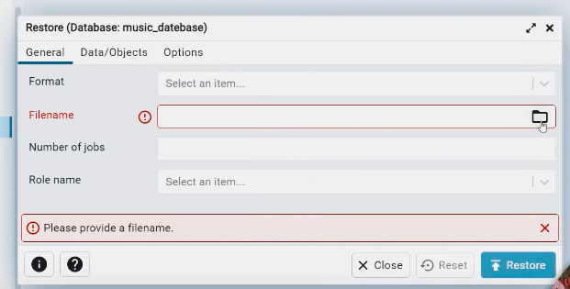

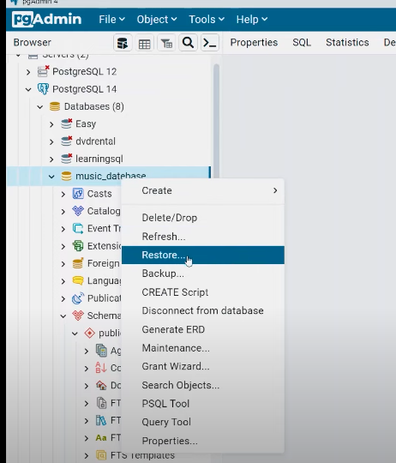

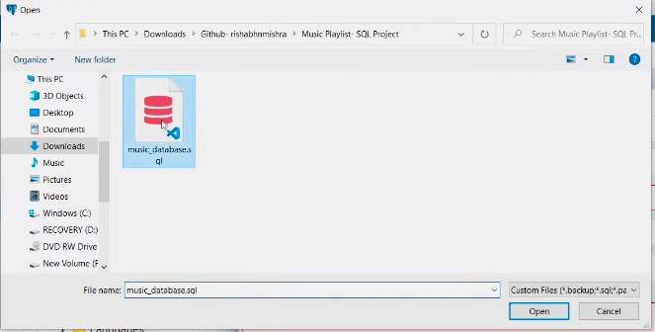

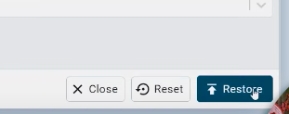

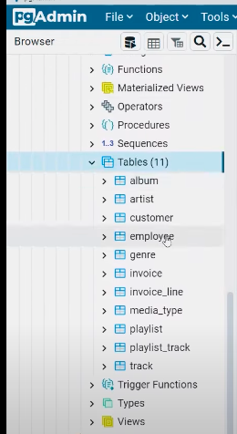

Now, you can see above, we got all the tables.

Now, click on the **Query Tool**

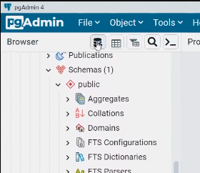

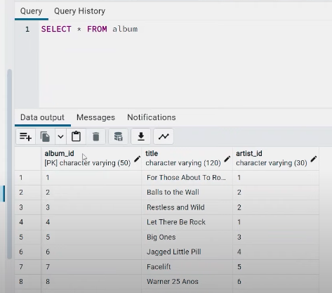

Let’s go to the questions and solve them:

**XXXXXXXXXXXXXXXXXXXXXXXXXXXXXXXX**

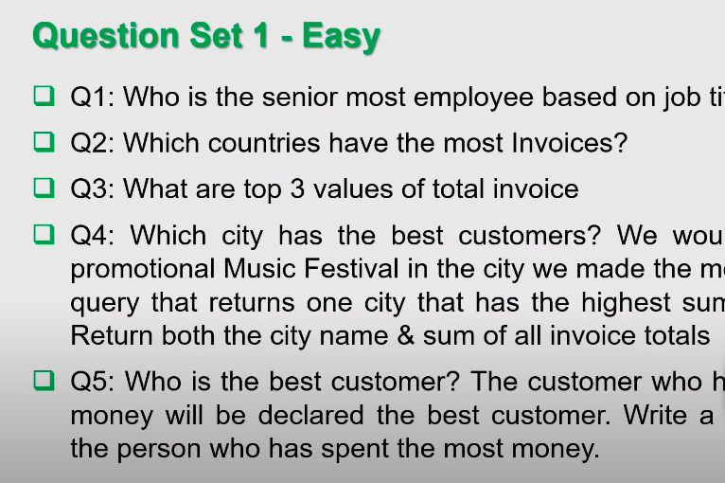



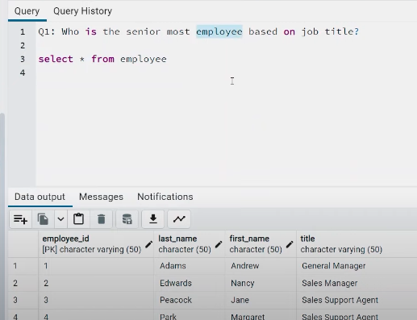

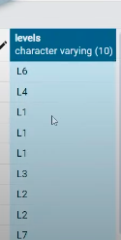

As by looking at the **levels** column, we can decide the Senior most employee

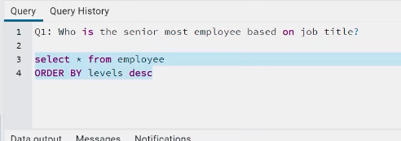

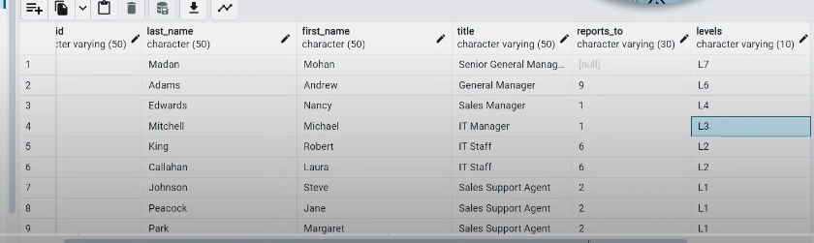

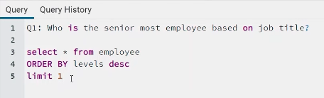

So, **Senior Gen Manager (Madan Mohan)** is the topmost with **level L7**

**XXXXXXXXXXXXXXXXXXXXXXXXXXXXXXXX**



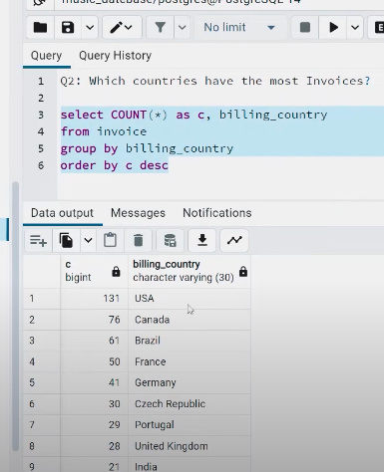

So, **USA** has the highest number of invoices.

**XXXXXXXXXXXXXXXXXXXXXXXXXXXXXXXX**



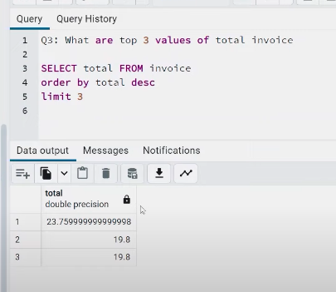

**XXXXXXXXXXXXXXXXXXXXXXXXXXXXXXXX**

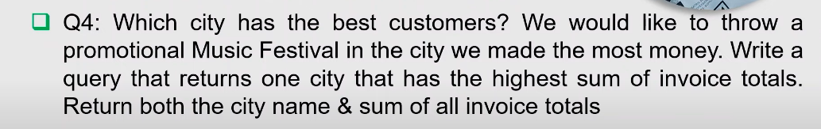

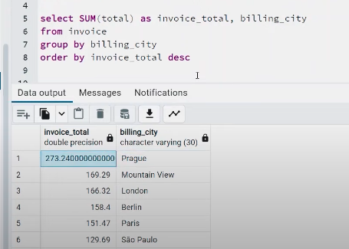

**XXXXXXXXXXXXXXXXXXXXXXXXXXXXXXXX**



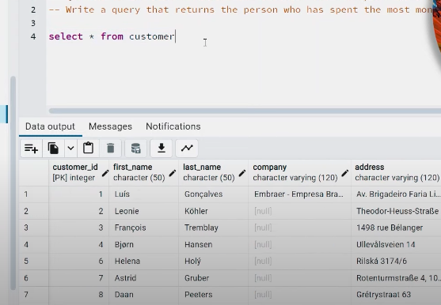

Here, we will have to connect the **customer** & **invoice** tables



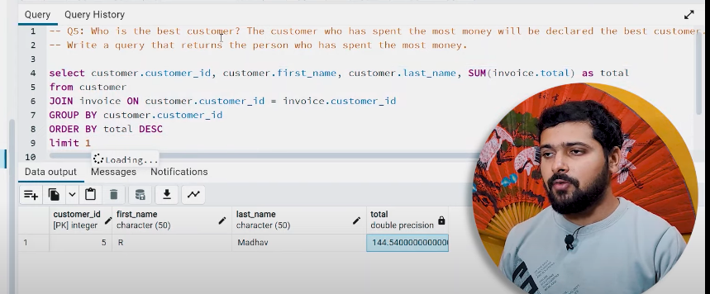

**XXXXXXXXXXXX END OF BASIC LEVEL XXXXXXXXXXXX**

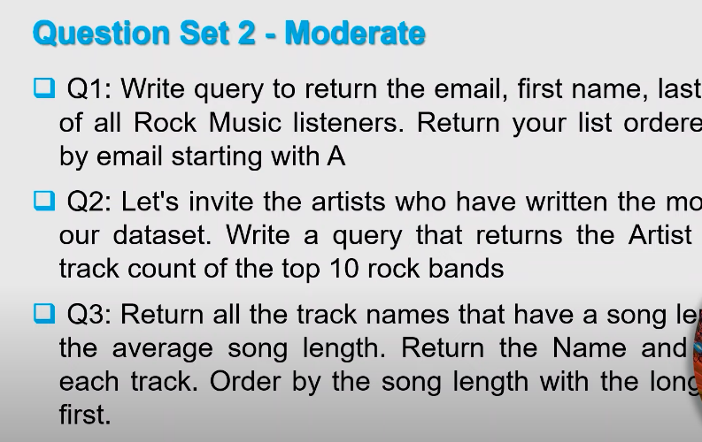

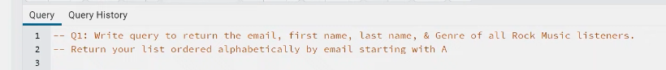

First, we have to look from which tables the data needs to be fetched.

For **email, First name, Last name** --> **Customer** Table

For **Genre** --> **Genre** Table



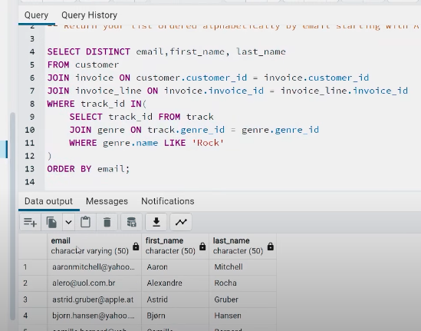

**XXXXXXXXXXXXXXXXXXXXXXXXXXXXXXXX**

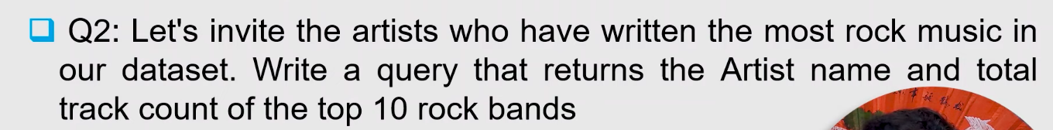

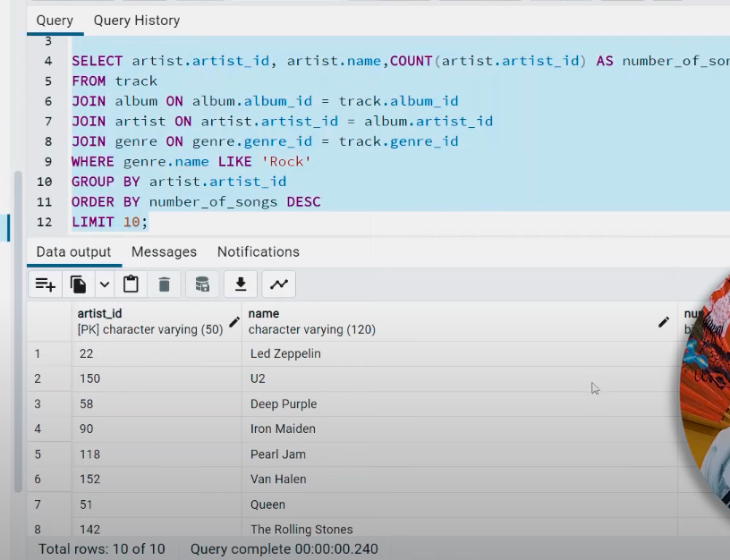

**XXXXXXXXXXXXXXXXXXXXXXXXXXXXXXXX**

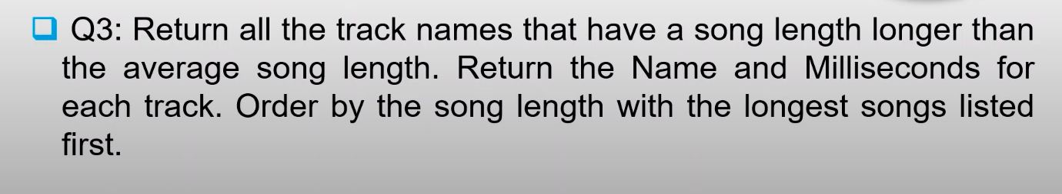

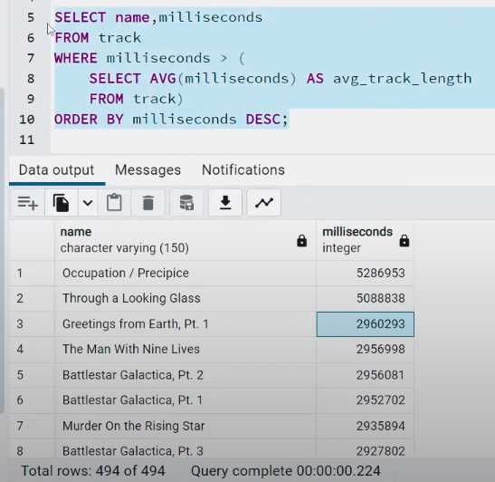

**XXXXXXXXXXXX END OF MODERATE LEVEL XXXXXXXXXXXX**

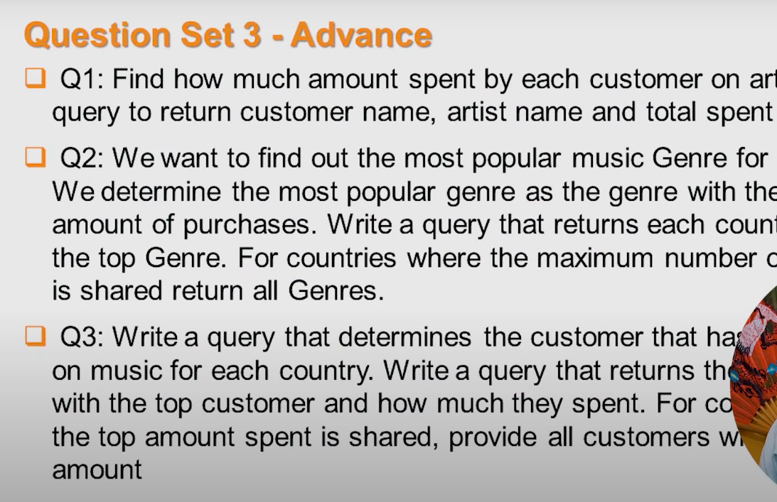



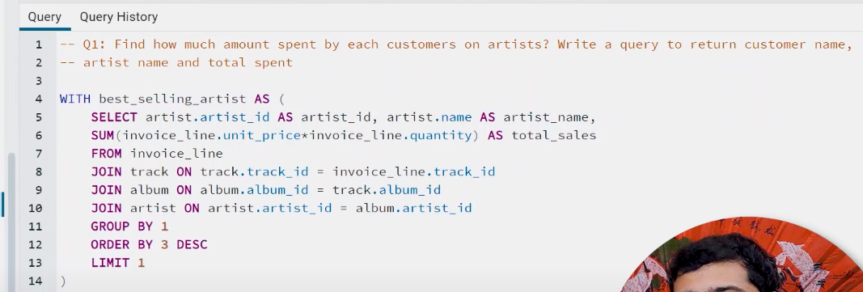

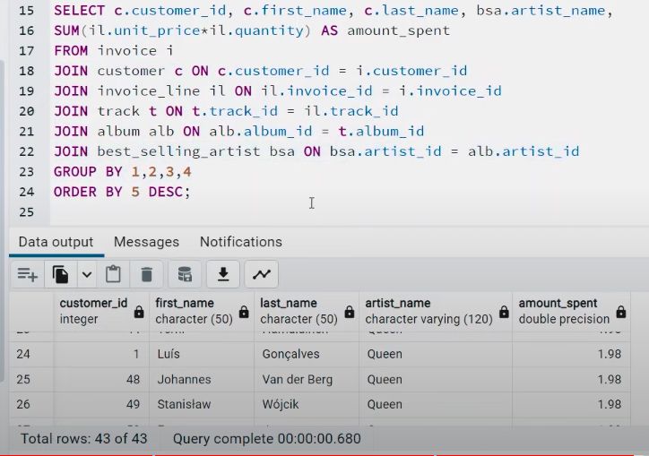

**XXXXXXXXXXXXXXXXXXXXXXXXXXXXXXXX**

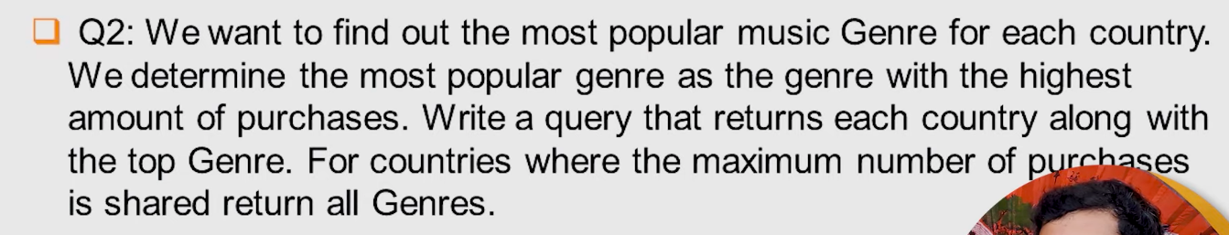

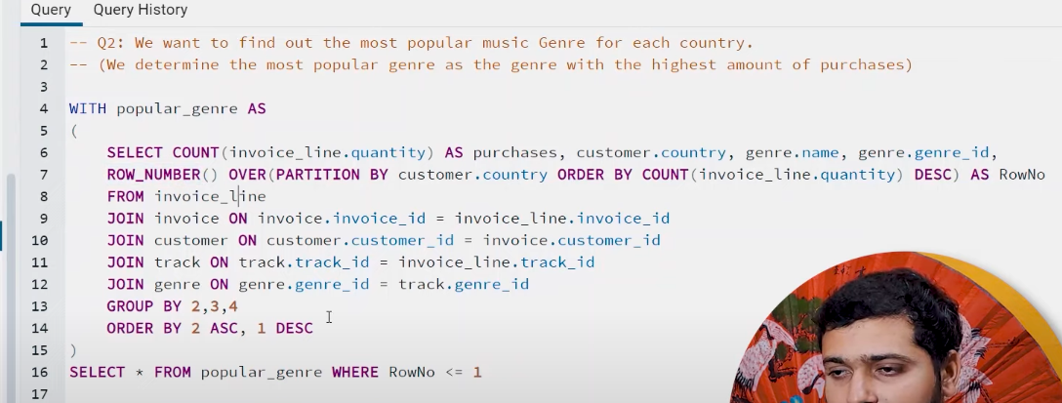

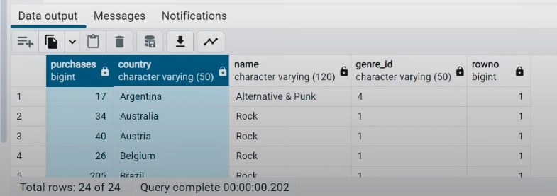

OR

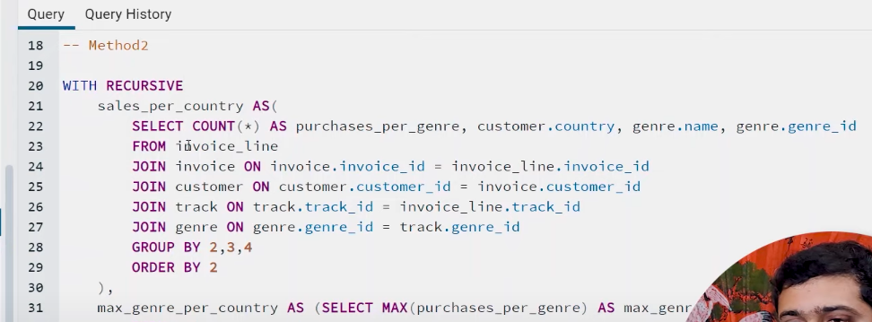

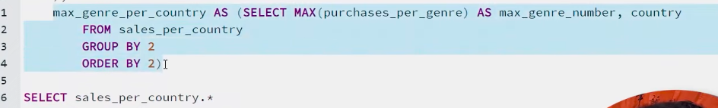

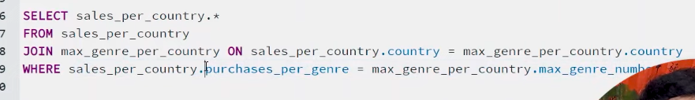

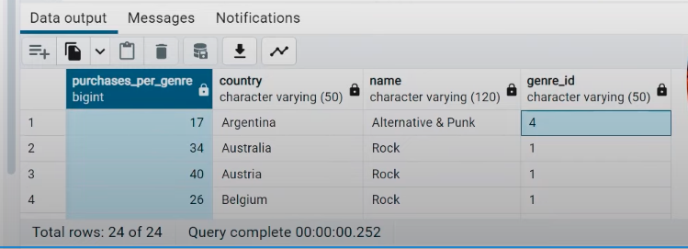

**XXXXXXXXXXXXXXXXXXXXXXXXXXXXXXXX**

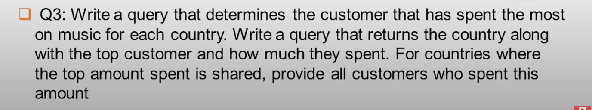

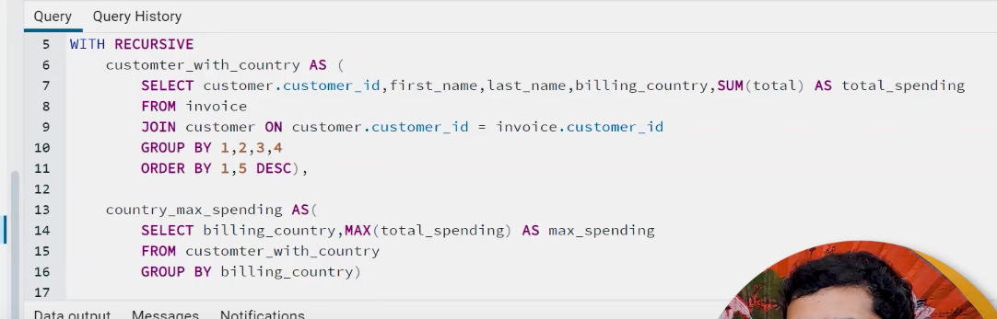

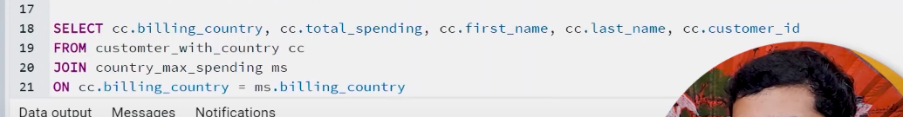

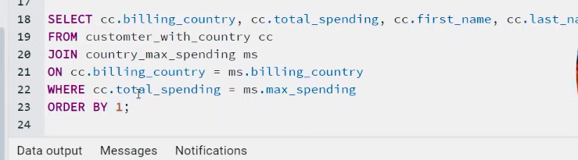

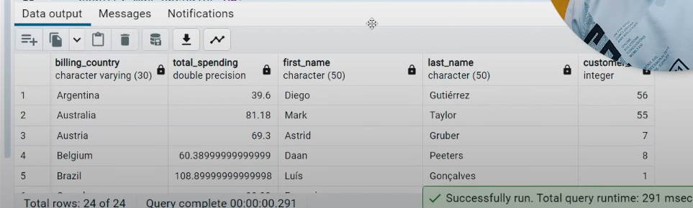

**OR**

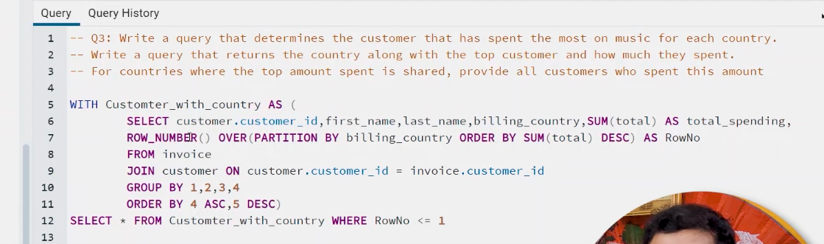

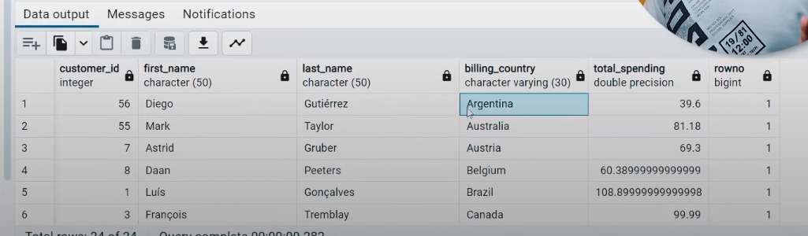

**XXXXXXXXXXXX END OF ADVANCE LEVEL XXXXXXXXXXXX**